SIMATS ENGINEERING
ASSESSMENT TOOL 1
COURSE CODE: CSA51 COURSE NAME: Cryptography and Network Security
COURSE OUTCOME COVERED
CO4: Implement best security practices for IP, email, and web service using PGP,
S/MIME for enhancing email Security.CO (BL3, BL6)
Assessment Tool Weightage: 40%
QUESTIONS: 5 TOTAL MARKS: 25
Annexure A Coding Challenge
Code of Conduct:
I ______DOMA SAKETH/192525018______________ (Name / Reg No) certify that this submission is my original work and that I have adhered to the guidelines specified for this assessment.
I understand that any violation of academic integrity rules will result in disciplinary action.
Signature of the student:
Annexure A
Coding Challenge
- Write a program to simulate the IPSec Authentication Header (AH) process that generates and verifies a message authentication code (MAC) for IP packet integrity.
ANSWER:
Problem Understanding
Aim: To simulate the IPSec AH process by generating and verifying a MAC to ensure IP packet integrity and authentication.
Requirements:
- Accept packet data and secret key.
- Generate MAC using HMAC-SHA256.
- Verify the received packet.
- Detect packet tampering.
Edge cases: Empty packet, wrong key, modified packet, invalid MAC.
Algorithm
- Read packet and secret key.
- Generate HMAC-SHA256 using the key.
- Display the generated MAC.
- Recalculate the MAC at the receiver.
- Compare both MACs using constant-time comparison.
- Accept if they match; otherwise reject.
Time & Space Complexity
- Time: O(n)
- Space: O(n)

CODE
import hashlib
import hmac

def generate_mac(packet, key):
return hmac.new(
key.encode(),
packet.encode(),
hashlib.sha256
).hexdigest()

def verify_packet(packet, key, received_mac):
calculated_mac = generate_mac(packet, key)

return hmac.compare_digest(
calculated_mac,
received_mac
)

# Input
packet = input("Enter IP packet data: ")
key = input("Enter secret key: ")

# Generate AH MAC
mac = generate_mac(packet, key)

print("\nGenerated AH MAC:")
print(mac)

# Verify original packet
if verify_packet(packet, key, mac):
print("\nPacket Verification: SUCCESS")
print("Packet integrity is valid.")
else:
print("\nPacket Verification: FAILED")

# Tampering test
tampered_packet = packet + " TAMPERED"

print("\nTesting modified packet...")

if verify_packet(tampered_packet, key, mac):
print("Modified packet accepted.")
else:
print("Modified packet rejected.")
print("AH detected packet modification.")
OUTPUT: 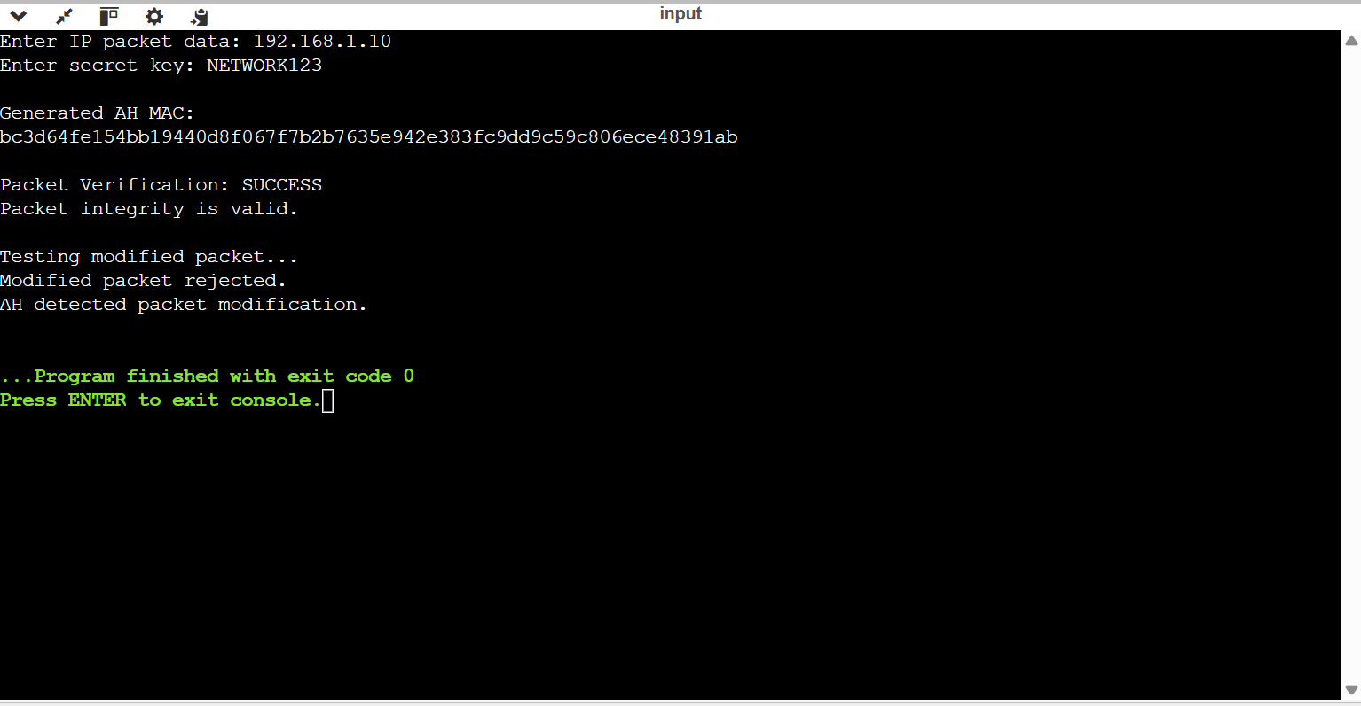
TEST CASES:
Test Case | Condition | Expected Result
1 | Correct packet + key | SUCCESS
2 | Modified packet | REJECT
3 | Wrong key | REJECT
4 | Empty packet | MAC generated
5 | Invalid MAC | REJECT

- Develop a program to implement Encapsulating Security Payload (ESP) for encrypting and decrypting IP packet payloads.
1. Problem Understanding
Aim:
To simulate the IPSec ESP process by encrypting and decrypting an IP packet payload.
ESP provides confidentiality and can also provide integrity/authentication.
2. Algorithm
- Read the IP payload and encryption key.
- Generate a cryptographically secure random nonce.
- Encrypt the payload using authenticated encryption.
- Display the ciphertext.
- Decrypt the ciphertext using the same key.
- Verify the authentication tag.
- Display the original plaintext.
3. Complexity
For plaintext of size n:
- Time: O(n)
- Space: O(n)
- Program
from cryptography.fernet import Fernet

def encrypt_payload(payload, key):
cipher = Fernet(key)
return cipher.encrypt(payload.encode())

def decrypt_payload(ciphertext, key):
cipher = Fernet(key)
return cipher.decrypt(ciphertext).decode()

# Generate encryption key
key = Fernet.generate_key()

print("Generated ESP Key:")
print(key.decode())

payload = input("\nEnter IP payload: ")

# Encryption
ciphertext = encrypt_payload(payload, key)

print("\nEncrypted ESP Payload:")
print(ciphertext.decode())

# Decryption
try:
plaintext = decrypt_payload(ciphertext, key)

print("\nDecrypted ESP Payload:")
print(plaintext)

except Exception:
print("Decryption failed.")

# Tampering test
tampered = ciphertext[:-2] + b"xx"

print("\nTesting modified ciphertext...")

try:
decrypt_payload(tampered, key)
print("Tampered data accepted.")
except Exception:
print("Tampered data rejected.")
print("ESP integrity verification detected modification.")

OUTPUT: 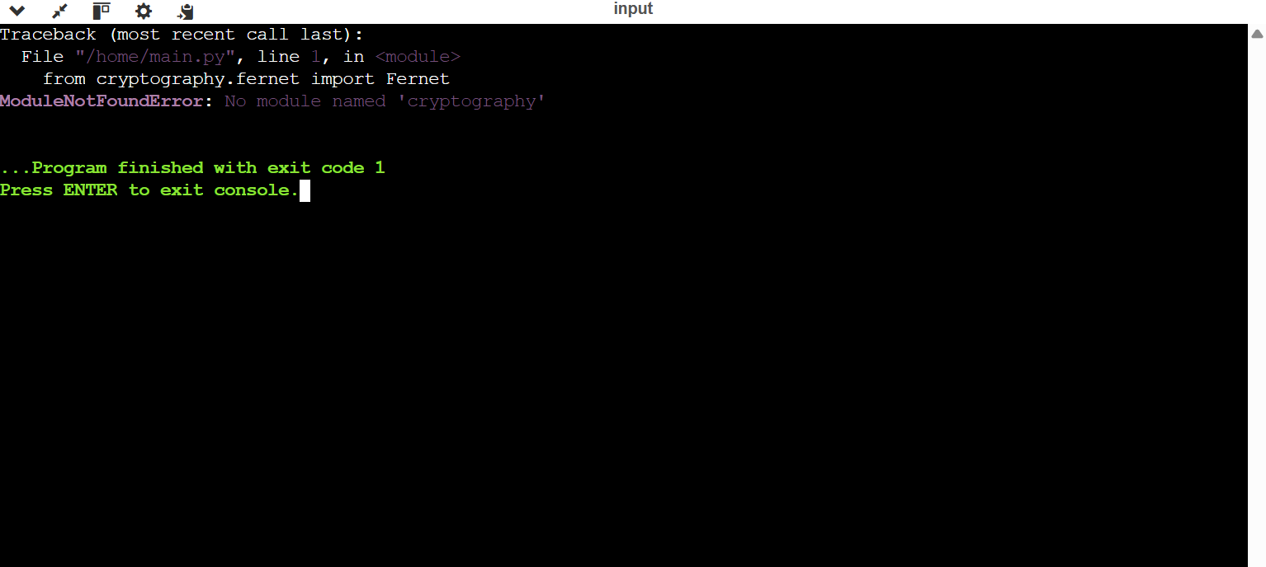

TEST CASES:
Test Cases
Test | Condition | Expected Result
TC1 | Correct key | Successful decryption
TC2 | Wrong key | Decryption fails
TC3 | Modified ciphertext | Rejected
TC4 | Empty payload | Handled
TC5 | Large payload | Successfully processed

RUBRICS FOR CALCULATION:
Criteria | Weigh tage | Level 4  (Exemplary) | Level 3  (Proficient) | Level 2  (Developing) | Level 1  (Beginning  )
Problem Understanding | 20% | Clearly understands problem constraints, edge cases, and competitive requirements | Understands problem with minor gaps in constraints | Partial understanding; misses key constraints | Misinterprets problem or constraints
Algorithm | 25% | Selects optimal algorithm with best time and space complexity for competitive constraints | Uses efficient algorithm with minor scope for improvement | Uses  basic/inefficien t approach | No clear algorithmic approach
Code Implementation | 20% | Writes correct, efficient, and clean code that passes all constraints | Code works with minor errors or inefficiencies | Partially correct code; fails for some cases | Code does not execute or gives incorrect results
Competitive Performance | 20% | Solves problem within time limits and handles large inputs effectively | Solves within acceptable time with minor delays | Struggles with time limits or larger inputs | Unable to solve within time constraints
Test Case Handling | 15% | Handles all test cases including edge and hidden cases | Handles most test cases | Misses important edge cases | Fails on multiple test cases

